cd=change Directories

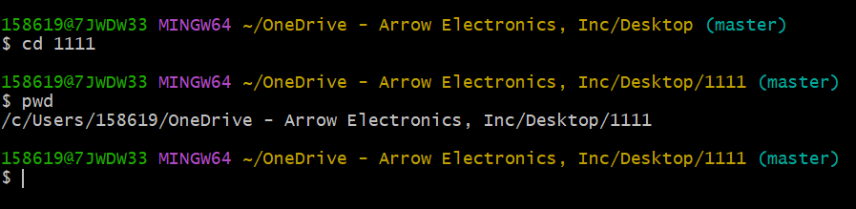

pwd=check present directories

ls=list directories content

